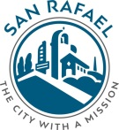

City of San Rafael
BID ADVISORY BOARD
San Rafael Business Improvement District
Bank of Marin
1101 Fourth Street
San Rafael CA 94901
Wednesday, March 8, 2017
8:00 AM – 9:00 AM

- Call to order
- Roll Call
- Approval of Minutes
- Public Comment
- Board Member Comments

Joint Meeting with the San Rafael Business Improvement District Nonprofit Board
- Events
  - May Madness
  - Target Funds
- Downtown BID Administration
  - Principal BID Office
  - April 3 Report to City Council
  - New BID Board members
  - BID Finances
  - Staffing
- Adjournment

