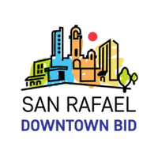
Board Meeting Agenda
Thursday, June 16, 2022, 10-11 AM
VIA ZOOM MEETING
Meeting ID: 822 1765 7338
Passcode: BID

- Call to Order/Roll Call/Introduction
- Approval of May Minutes *
- President’s Report - Jed
- Executive Director’s Report - Sarah
- City Updates- Victoria
- Thursday Nights/Farmer’s Market/DUTL - Events Committee, Sarah, Amy, Terrance, Jaime, Ryan
- BID Night at the Pacifics Game, Tuesday, June 21st - Sarah
  - Review & Select Nominations for:
    - Singing the National Anthem
    - Throwing out the 1st Pitch
  - Need more goodie bag items, any thoughts?
- BID Committee Report from DSRAD/Beautification - Morgan, Elizabeth, Meg
- Public/Guest Comments
- Roundtable check-in/next agenda suggestions, all
- Adjourn
*action items

Next Meeting: Thursday, July 21st, 2022, 10 AM via Zoom
The mission of the Downtown San Rafael Business Improvement District is to promote the common interests of business owners for the purpose of maintaining and developing a welcoming place to shop, dine, work, play and live.

